Performance Testing
Date | 07 October 2026
Team ID | SWTID-2026-2617
Project Name | EduGenie - Google Gemini Powered Learning Assistant
Maximum Marks | 5 Marks
Performance Testing
Performance testing evaluates how your system behaves under expected and peak load conditions. Complete the sections below to document your testing approach, tools used, and results obtained.
Step 1: Testing Overview
Field | Details
Testing Tool Used | Locust (Python load testing tool)
Type of Testing | Load Testing
Target Module / API | Ask EduGenie endpoint: GET /qa?question=What is Java?
Test Environment | Local (Uvicorn server at 127.0.0.1:8000), Google Gemini API over the internet
Test Date | 6 October 2026
Step 2: Test Scenarios
S.No | Test Scenario / Description | No. of Virtual Users | Duration (sec) | Expected Outcome
1 | Learners ask the question "What is Java?" through the /qa endpoint at the same time | 5 | 60 | All requests succeed; error rate below 1%
Step 3: Performance Test Results
S.No | Metric | Target Value | Actual Value | Status (Pass / Fail) | Remarks
1 | Response Time (Avg) | < 2 seconds | 9.7 seconds (9740 ms) | Fail | Raised by the first few slow requests; median was 0.33 seconds.
2 | Response Time (Max) | < 5 seconds | 48.0 seconds (47950 ms) | Fail | Slowest requests came at the start of the test.
3 | Throughput (Req/sec) | - | 0.42 req/sec | - | 25 requests in 60 seconds with 5 users.
4 | Error Rate | < 1% | 0% (0 of 25 failed) | Pass | All requests completed successfully.
5 | CPU Utilization | < 80% | 1% | Pass | Task Manager reading taken right after the test finished.
6 | Memory Utilization | < 80% | 46% | Pass | Task Manager reading taken right after the test finished.
Step 4: Observations & Analysis
Key Findings:
5 virtual users sent 25 requests in 60 seconds and all of them succeeded (0 failures, 0% error rate).
After the first few requests, responses came back quickly: the median response time was 0.33 seconds. CPU (1%) and memory (46%) stayed far below the 80% limit.
An earlier run on 5 October 2026 (53 requests, 0 failures, average 3.6 seconds) showed the same pattern.
Bottlenecks Identified:
The first few requests of the test were very slow (33 to 48 seconds), which raised the average to 9.7 seconds and the maximum to 48.0 seconds, above the targets. Possible cause: start-up delay and the response time of the Gemini API.
Optimization Steps Taken:
No optimization was applied during this test run. Planned improvements: handle Gemini calls asynchronously with a timeout, and cache answers for repeated questions.
Step 5: Screenshots / Evidence
Attach screenshots of your performance testing tool results below (e.g., JMeter report, Locust graphs, k6 output):
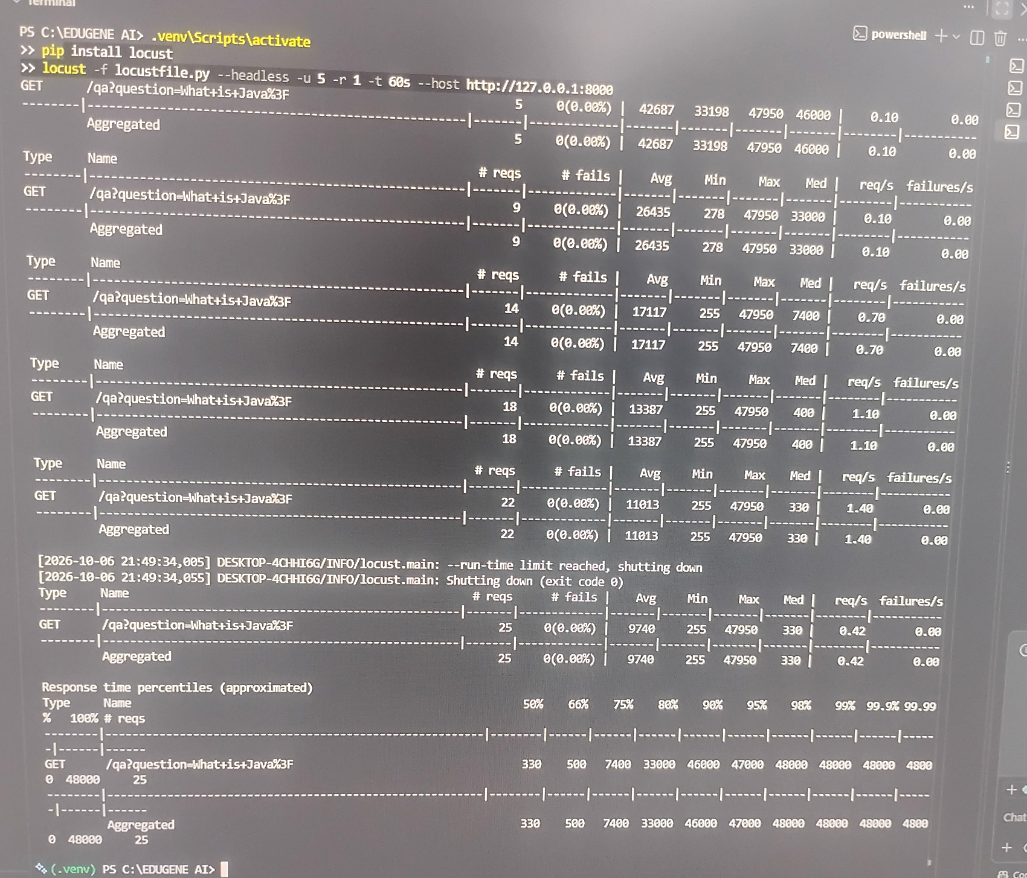
Screenshot 1: Locust output (5 users, 60 seconds)
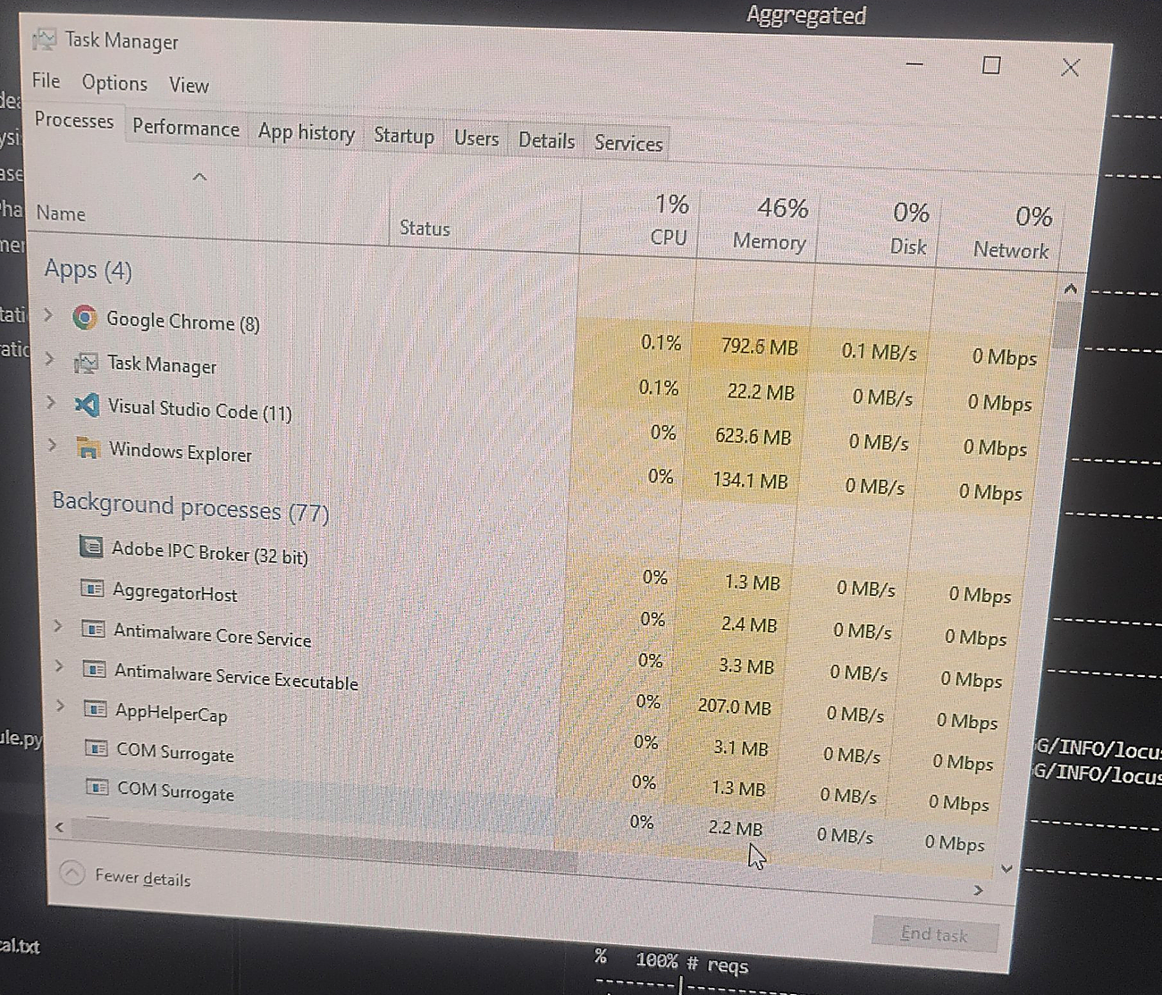
Screenshot 2: Task Manager (CPU and Memory)

